# Overview: Creating Content with AI

In this lesson, we will delve into the fascinating world of creating content with AI, exploring how generative AI technologies can bring your creative visions to life. By leveraging tools like deep-learning face animation and text-to-image generation, you can produce professional-quality digital media that stands out.

Get ready to turn your creativity into reality with the power of AI.

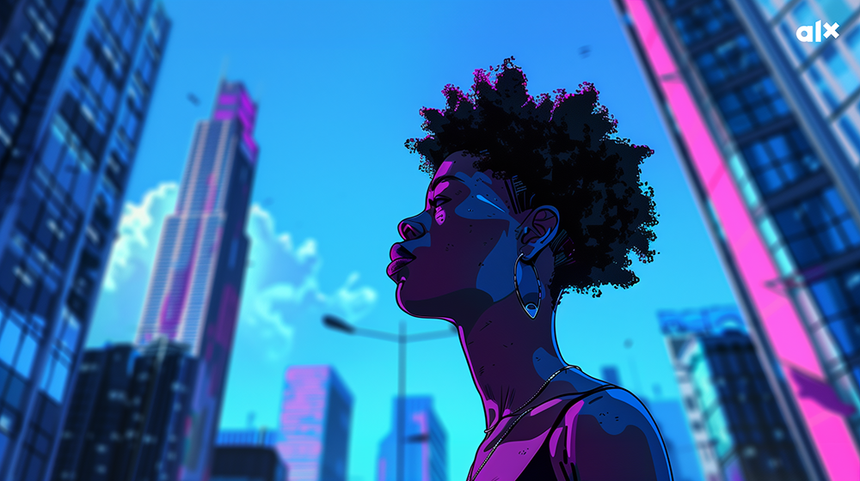

### **What You’ll Learn:**

Discover How to Turn Your Creativity Into Reality

Discover how AI can transform your creative ideas into professional-quality digital content, making it easier to bring your visions to life.

Produce Professional-Quality Digital Media

Get hands-on experience generating AI images, videos, and even music to tell stories. Discover how to generate ideas, write scripts, and write prompts to help visualize the story and create immersive content.

### **Ready to dive in?**

What excites you most about creating content with AI: images, videos, music, or something else?

# Turning Your Creativity Into Reality



#### **Story Time!**

Hi, I’m Stefan! I think it is fair to say I was one of the **original AI-empowered people at ALX**.

I joined the ALX team in 2023 just as ChatGPT hit the world. From day one, I saw this tool’s value and have kept my eye on AI tools ever since. At the time, I was creating projects for Data Science and Data Analytics courses, and I wanted to use AI to build these projects. This is how the world of Maji Ndogo and the city of Bahari came to be—all AI-powered!

I dreamed of telling a story that **many of you know all too well**. Many of us face infrastructure collapse across Africa because of corruption, greed, mismanagement, and often limited resources. I wanted a **leader to rise up** and change things for her people by **being brave, compassionate, and passionate.** More importantly, I wanted **AI, data, and data science** to guide her in making the right choices for the people of Maji Ndogo. We told this through a story about a country struggling to provide water infrastructure.

Everything – from the story idea, the country, the towns, street names, people’s names, and mountains of data – **was created by collaborating with ChatGPT**. I remember calculating that I exchanged one million words with ChatGPT in just six months. That’s the equivalent of the entire Harry Potter series or the Game of Thrones books! With ChatGPT, I created the story, thousands of lines of code, video scripts, and even an entire virtual world for this course, but nothing worked without my guidance, rewriting, using my own creativity, and collaborating with my team. AI tools often produce results that require extensive work, and using them without humans in the loop creates soulless content. So, when you use these tools, empower yourself and your creativity rather than relying on them to do all the work.

We wanted to create a video to tell this story, but making a video with many scenes and characters is insanely time-consuming. When Midjourney launched, I spent a weekend creating a storyboard for the team, telling the story of Maji Ndogo.

Only when I pitched the idea to the rest of the team did I understand what I had created. I tried to take the place of an animator and gave their job to AI. People were a little shocked – some were angry, some disappointed, and some excited at what I had created, but I regretted it. This will be true for anyone using AI tools at work. **AI brings irreversible change to our lives**, and there is no going back now. So, learn from my experience and consider how you use AI tools and how this might impact others.

After reflecting, the team saw the opportunity this brought. We could use AI image generation tools to tell stories and create an impact in Africa with fewer resources. Our entire production team worked on that video for almost a month. They poured their souls into that project, and it is their skillful manipulation of the AI tools, unleashed creativity, and collaboration with each other that improved my first terrible version to what you see here:

So what are the lessons here?

1. Unleash Your Creativity: AI tools like ChatGPT helped me create characters, tell a story, and develop a world-class learning experience. Midjourney **brought my ideas and story to life**.
2. Empower People: Introducing AI results wasn’t easy for everyone to accept. It’s **important to empower people with AI** over time and be open to feedback.
3. Collaborate and Refine: While AI got us 70% of the way, **the final 30% required significant human effort**. Creating a polished product took more than 800 hours! **AI can simplify initial creation**. However, refinement still relies on our creativity and collaboration, not to mention the thousands of images we generated that didn’t work. Sometimes, I still have nightmares…

In this lesson, we’ll take the steps I took and tell a story using AI. We’ll **use a large language model** to help us **think creatively**, generate prompts for image, video, and audio generators, and then **use free creative AI tools to bring our story to life**. Along the way, we’ll learn valuable lessons about creativity, collaboration, and the power of AI.

# Writing creatively with LLMs



AI is a very useful tool for unleashing our creativity. We have the power of an illustrator, video animator, or scriptwriter at the press of a button.

So, instead of just discussing how these work, let’s build something. Let’s tell a story using AI tools together! The first step is to use an LLM to help us think about a story, create a script for it, and let it generate prompts we can use for images.

Finding a story

Finding a story to tell is sometimes hard. If you need some inspiration, head to one of the LLMs we used before and try the following prompt:

Prompt

I want you to act as a storyteller. You will come up with entertaining stories that are engaging, imaginative, and captivating for the audience. It can be fairy tales, educational stories, or any other type of story that has the potential to capture people’s attention and imagination. Depending on the target audience, you may choose specific themes or topics for your storytelling session, e.g., if it’s children, then you can talk about animals; If it’s adults, then history-based tales might engage them better, etc. My first request is “A story about Africa and AI.”

Claude, Gemini, and Llama are all great choices for this task.

This is the idea that I liked:

**The Festival of Lights**

In a small town, the annual Festival of Lights is a time of joy and celebration. This year, the festival committee decides to use AI to enhance the event with innovative light displays, interactive exhibits, and a digital storytelling booth that shares stories from the community.

Creating a story

Writing the script is the first crucial step in our storytelling process. It lays the foundation for everything else – from the visuals to the video production. A well-crafted script will help us capture the essence of the Festival of Lights, including the preparations, the event itself, and the personal stories of the villagers. We’ll use AI to assist in **generating ideas**, **structuring the story**, and adding creative touches.

You can use the following prompt to generate some story scripts:

Prompt

I want you to act as a screenwriter. You will develop an engaging and creative script for a social media post that can captivate its viewers. Start by coming up with interesting characters, the setting of the story, dialogues between the characters, etc. Once your character development is complete - create an exciting storyline filled with twists and turns that keep viewers in suspense until the end.

My story idea is:

{Paste your story in here}

This is what I got:

Results

I got that on my first try. As always, AI tends to not really capture emotion well like this part:

*Kwame: (Excitedly) Amina, you’ve got to see this! I’ve programmed the AI to design interactive light displays for the festival. Imagine the possibilities!*

*Amina: (Skeptical) I don’t know, Kwame. Technology is great, but what if it takes away from the human touch? Stories and art are meant to be personal.*

These two characters seem to have very different values, so it makes sense to me to make their conflict a little more emotionally charged. I gave ChatGPT that feedback, focusing its attention on a specific part and improving it. We can do this over and over to get the story we want.

Prompt  
“Kwame: (Excitedly) Amina, you’ve got to see this! I’ve programmed the AI to design interactive light displays for the festival. Imagine the possibilities! Amina: (Skeptical) I don’t know, Kwame. Technology is great, but what if it takes away from the human touch? Stories and art are meant to be personal. It seems like these two characters have very different values, so it makes sense to me to make their conflict a little more emotionally charged. ”

This is what I ended up with:

Results

I think this version captures the conflict a bit better, right?

Creating prompts to generate visuals

Then, for each image we want to use, we can use this prompt, adapted to suit our story. Adding additional context, like scenes, basic characters, and the full story to the prompt, gives the LLM a clearer idea of what we want.

Prompt

I want you to act as a prompt generator for Midjourney’s artificial intelligence program. Your job is to provide detailed and creative descriptions that will inspire unique and interesting images from the AI. Keep in mind that the AI is capable of understanding a wide range of language and can interpret abstract concepts, so feel free to be as imaginative and descriptive as possible. For example, you could describe a scene from a futuristic city or a surreal landscape filled with strange creatures. The more detailed and imaginative your description, the more interesting the resulting image will be. Create image descriptions of each scene in this African town, and create character descriptions I can use for each of the characters. If a character appears in a scene, describe them in the scene and be consistent so we get the same character each time.

Scenes:

A quaint town square decorated with colorful lanterns and bustling with activity as townspeople prepare for the Festival of Lights.

Kwame’s workshop, cluttered with gadgets and tech projects. Amina walks in, curious but wary.

Town square, as volunteers set up booths and decorations. Kwame and Tunde are installing the AI-powered light displays.

Town square, as volunteers set up booths and decorations. Kwame and Tunde are installing the AI-powered light displays.

The festival is in full swing with music, dancing, and the mesmerizing AI-powered light displays. The townspeople are in awe.

The digital storytelling booth, where people can interact with the AI to hear stories. Amina, after much thought, decides to share one of her stories.

The end of the festival, as people are gathered around the storytelling booth, sharing their experiences.

Characters:

Kwame, - a young African mad scientist character using AI to solve any problem he can find

Amina - a middle-aged woman that is conservative and true to her cultural heritage

Tunde- a young man destined for great adventures.

Story:

**Scene 1: Introduction**

Setting: A quaint town square decorated with colorful lanterns and bustling with activity as townspeople prepare for the Festival of Lights.

Narrator (Esi): (Voiceover) Every year, our small town of Bahari comes alive with the Festival of Lights. It’s a time of joy, unity, and celebration. This year, we decided to blend tradition with innovation, introducing AI to create an unforgettable experience.

**Scene 2: Meet Kwame and Amina**

Setting: Kwame’s workshop, cluttered with gadgets and tech projects. Amina walks in, curious but wary.

Kwame: (Excitedly)*Amina, you’ve got to see this! I’ve programmed the AI to design interactive light displays for the festival. Imagine the possibilities!*

Amina: (Frustrated)*Kwame, don’t you see? Technology is great, but what if it takes away from the human touch? Stories and art are meant to be personal, not automated by some machine!*

Kwame: (Defensive)*But Amina, this isn’t about replacing people. It’s about enhancing our experience, making the festival more magical than ever before!*

Amina: (Angry)*Magic? You think a machine can understand the soul of our stories? Our art? You’re missing the point, Kwame. This festival is about our community, our traditions, not some flashy tech gimmick!*

Kwame: (Hurt)*Amina, I’m not trying to erase our traditions. I just want to show that we can move forward without losing who we are.*

Amina: (Softening slightly)*I know you mean well, Kwame. But I’m scared that in our rush to embrace the future, we’ll forget what makes our past so special.*

**Scene 3: Festival Preparations**

Setting: Town square, as volunteers set up booths and decorations. Kwame and Tunde are installing the AI-powered light displays.

Tunde: (Grinning) *This is going to be epic! I can’t wait to see everyone’s reaction.*

Kwame: (Focused) *Me too, Tunde. But I hope Amina comes around. Her stories would add so much to the digital storytelling booth.*

**Scene 4: The Festival Begins**

Setting: The festival is in full swing with music, dancing, and the mesmerizing AI-powered light displays. The townspeople are in awe.

Narrator (Esi): (Voiceover)*The night of the festival arrived, and Bahari was transformed. The AI light displays were a sight to behold, but there was still something missing…*

**Scene 5: The Twist**

Setting: The digital storytelling booth, where people can interact with the AI to hear stories. Amina, after much thought, decides to share one of her stories.

Amina: (Softly)*Alright, let’s see what this AI can do. I’ll share my story and see how it brings it to life.*

The AI animates Amina’s story with vibrant visuals and dynamic narration, captivating the audience.

Kwame: (Amazed) *Amina, this is incredible! Your story combined with the AI… it’s magical.*

**Scene 6: The Resolution**

Setting: The end of the festival, as people are gathered around the storytelling booth, sharing their experiences.

Narrator (Esi): (Voiceover)*That night, we witnessed the perfect blend of tradition and technology. The AI didn’t overshadow human creativity; it enhanced it. Amina’s story, brought to life with AI, showed us that innovation could coexist with our cherished traditions.*

**Scene 7: Conclusion**

Setting: Kwame and Amina stand together, watching the last of the festival lights fade.

Amina: (Smiling)*You were right, Kwame. AI isn’t here to replace us. It’s here to help us tell our stories in new and exciting ways.*

Kwame: (Grinning)*I knew you’d come around, Amina. Just wait till next year’s festival!*

Narrator (Esi): (Voiceover) *And so, in Bahari, we learned that by embracing the future, we could honour the past and create something truly special. Until next year’s Festival of Lights…*

*Fade out with a view of the town, the lights twinkling like stars.*

This is what I got:

Results

**Scene 1: A Quaint Town Square**

Description:

The town square of Bahari is alive with vibrant activity as the townspeople prepare for the annual Festival of Lights. Colourful lanterns hang from strings crisscrossing above, creating a canopy of brilliant hues. Stalls and booths line the cobblestone pathways, selling handmade crafts and traditional foods. Children run about, laughing and playing, while adults decorate and set up for the evening’s festivities. The sky is a deepening twilight, with the first stars beginning to twinkle.

Characters:

Kwame: A young African mad scientist with a passion for using AI to solve problems. He has a lean build, always wears glasses, and is often seen in a slightly dishevelled state due to his constant tinkering with gadgets. His workshop is his sanctuary, filled with tools, half-finished projects, and the hum of AI devices.

Amina: A middle-aged woman who values tradition and cultural heritage. She wears colourful traditional clothing and a headscarf, embodying the spirit of her community. Her expressions are often serious and thoughtful, but she has a warm heart.

Tunde: A young man with an adventurous spirit. He is tall and athletic, with a bright smile and an infectious enthusiasm. He often helps Kwame with his projects, eager to learn and explore new ideas.

**Scene 2: Kwame’s Workshop**

Description:

Kwame’s workshop is a chaotic but fascinating place, filled with gadgets, tools, and various tech projects in different stages of completion. Shelves are crammed with electronic parts, and the workbench is cluttered with wires and circuit boards. The room is dimly lit, with the soft glow of computer screens and the occasional flicker of a soldering iron.

Characters:

Kwame: Enthusiastically demonstrating his latest AI project, his eyes bright with excitement. His hair is slightly messy, and he wears a lab coat over his casual clothes.

Amina: Standing at the entrance, her posture rigid and arms crossed. She looks around with a mix of curiosity and wariness, her expression showing scepticism about the high-tech surroundings.

**Scene 3: Festival Preparations**

Description:

The town square is bustling with volunteers setting up booths and decorations for the Festival of Lights. Colourful banners and flags flutter in the breeze, and tables are being arranged with various traditional items and foods. The air is filled with a sense of anticipation and excitement.

Characters:

Kwame: Working diligently with Tunde to install the AI-powered light displays. He is focused and precise, occasionally adjusting his glasses as he works.

Tunde: Grinning broadly as he helps Kwame. His enthusiasm is palpable, and he chats with the other volunteers, sharing his excitement about the upcoming festival.

**Scene 4: The Festival Begins**

Description:

As night falls, the festival comes to life. Music fills the air, and people dance joyfully in the streets. The AI-powered light displays illuminate the square with stunning patterns and colours, creating a magical atmosphere. The lanterns overhead add to the enchanting scene, casting a warm, festive glow.

Characters:

Kwame: Watching the light displays with a mix of pride and nervousness, hoping that the townspeople will appreciate his efforts.

Amina: Observing the festival with a thoughtful expression, slowly beginning to see the beauty in the combination of tradition and technology.

**Scene 5: The Digital Storytelling Booth**

Description:

A booth in the town square is dedicated to digital storytelling, where people can interact with an AI to hear and share stories. The booth is decorated with traditional motifs and has a large screen displaying dynamic visuals that accompany the stories being told.

Characters:

Amina: After much hesitation, she steps into the booth and begins to share one of her cherished stories. Her voice is soft but gains confidence as she sees the AI bringing her story to life with vibrant visuals.

Kwame: Standing nearby, watching in awe as Amina’s story captivates the audience. He smiles, realizing that this is the moment he had hoped for.

**Scene 6: The Festival’s Climax**

Description:

The festival reaches its peak as people gather around the storytelling booth, mesmerized by the AI-animated stories. The atmosphere is filled with a sense of wonder and unity, as the townspeople share their experiences and marvel at the blend of tradition and technology.

Characters:

Amina: Now fully engaged, she interacts with the audience, answering questions and sharing more stories. Her initial scepticism has transformed into appreciation.

Kwame: Radiating pride and joy, knowing that his efforts have helped bring the community together in a new and meaningful way.

**Scene 7: The Festival’s Conclusion**

Description:

As the festival winds down, the town square is bathed in the soft glow of the remaining lanterns. People linger, chatting and reflecting on the evening’s events. The storytelling booth is still a focal point, with a small crowd sharing their thoughts and stories.

Characters:

Kwame: Standing next to Amina, both of them watching the last of the festival lights fade. Kwame’s expression is one of contentment, knowing that he has made a positive impact.

Amina: Smiling warmly, she looks at Kwame with newfound respect and understanding. She places a hand on his shoulder, acknowledging his vision and the harmony it has brought to their community.

With our image prompts, we now have a visual narrative of the Festival of Lights. Although we used a couple of prompts, they all follow the same principles - **“You are a… Do this… in this way… using this context…”** We were able to create a story, expand on it, refine it, and prepare it for the next step, creating visuals, only using one tool, the LLM. All within a couple of minutes!

For the most part, most online AI tools are just an LLM and good prompts underneath, so if we use a good prompt, we get the same results for free.

These images will help us convey the story more effectively and set the stage for the next step – creating images for our video. By combining our script with these visuals, we’re one step closer to bringing the festival to life.

# Writing creatively with LLMs



AI is a very useful tool for unleashing our creativity. We have the power of an illustrator, video animator, or scriptwriter at the press of a button.

So, instead of just discussing how these work, let’s build something. Let’s tell a story using AI tools together! The first step is to use an LLM to help us think about a story, create a script for it, and let it generate prompts we can use for images.

Finding a story

Finding a story to tell is sometimes hard. If you need some inspiration, head to one of the LLMs we used before and try the following prompt:

Prompt

I want you to act as a storyteller. You will come up with entertaining stories that are engaging, imaginative, and captivating for the audience. It can be fairy tales, educational stories, or any other type of story that has the potential to capture people’s attention and imagination. Depending on the target audience, you may choose specific themes or topics for your storytelling session, e.g., if it’s children, then you can talk about animals; If it’s adults, then history-based tales might engage them better, etc. My first request is “A story about Africa and AI.”

Claude, Gemini, and Llama are all great choices for this task.

This is the idea that I liked:

**The Festival of Lights**

In a small town, the annual Festival of Lights is a time of joy and celebration. This year, the festival committee decides to use AI to enhance the event with innovative light displays, interactive exhibits, and a digital storytelling booth that shares stories from the community.

Creating a story

Writing the script is the first crucial step in our storytelling process. It lays the foundation for everything else – from the visuals to the video production. A well-crafted script will help us capture the essence of the Festival of Lights, including the preparations, the event itself, and the personal stories of the villagers. We’ll use AI to assist in **generating ideas**, **structuring the story**, and adding creative touches.

You can use the following prompt to generate some story scripts:

Prompt

I want you to act as a screenwriter. You will develop an engaging and creative script for a social media post that can captivate its viewers. Start by coming up with interesting characters, the setting of the story, dialogues between the characters, etc. Once your character development is complete - create an exciting storyline filled with twists and turns that keep viewers in suspense until the end.

My story idea is:

{Paste your story in here}

This is what I got:

Results

**Scene 1: Introduction**

Setting: A quaint town square decorated with colourful lanterns and bustling with activity as townspeople prepare for the Festival of Lights.

Narrator (Esi): (Voiceover) Every year, our small town of Bahari comes alive with the Festival of Lights. It’s a time of joy, unity, and celebration. This year, we decided to blend tradition with innovation, introducing AI to create an unforgettable experience.

**Scene 2: Meet Kwame and Amina**

Setting: Kwame’s workshop, cluttered with gadgets and tech projects. Amina walks in, curious but wary.

Kwame: (Excitedly)*Amina, you’ve got to see this! I’ve programmed the AI to design interactive light displays for the festival. Imagine the possibilities!*

Amina: (Skeptical)*I don’t know, Kwame. Technology is great, but what if it takes away from the human touch? Stories and art are meant to be personal.*

**Scene 3: Festival Preparations**

Setting: Town square, as volunteers set up booths and decorations. Kwame and Tunde are installing the AI-powered light displays.

Tunde: (Grinning)*This is going to be epic! I can’t wait to see everyone’s reaction.*

Kwame: (Focused)*Me too, Tunde. But I hope Amina comes around. Her stories would add so much to the digital storytelling booth.*

**Scene 4: The Festival Begins**

Setting: The festival is in full swing with music, dancing, and the mesmerizing AI-powered light displays. The townspeople are in awe.

Narrator (Esi): (Voiceover)*The night of the festival arrived, and Bahari was transformed. The AI light displays were a sight to behold, but there was still something missing…*

**Scene 5: The Twist**

Setting: The digital storytelling booth, where people can interact with the AI to hear stories. Amina, after much thought, decides to share one of her stories.

Amina: (Softly)*Alright, let’s see what this AI can do. I’ll share my story and see how it brings it to life.*

The AI animates Amina’s story with vibrant visuals and dynamic narration, captivating the audience.

Kwame: (Amazed)*Amina, this is incredible! Your story combined with the AI… it’s magical.*

**Scene 6: The Resolution**

Setting: The end of the festival, as people are gathered around the storytelling booth, sharing their experiences.

Narrator (Esi): (Voiceover)*That night, we witnessed the perfect blend of tradition and technology. The AI didn’t overshadow human creativity; it enhanced it. Amina’s story, brought to life with AI, showed us that innovation could coexist with our cherished traditions.*

**Scene 7: Conclusion**

Setting: Kwame and Amina stand together, watching the last of the festival lights fade.

Amina: (Smiling)*You were right, Kwame. AI isn’t here to replace us. It’s here to help us tell our stories in new and exciting ways.*

Kwame: (Grinning)*I knew you’d come around, Amina. Just wait till next year’s festival!*

Narrator (Esi): (Voiceover)*And so, in Bahari, we learned that by embracing the future, we could honour the past and create something truly special. Until next year’s Festival of Lights…*

Fade out with a view of the town, the lights twinkling like stars.

I got that on my first try. As always, AI tends to not really capture emotion well like this part:

*Kwame: (Excitedly) Amina, you’ve got to see this! I’ve programmed the AI to design interactive light displays for the festival. Imagine the possibilities!*

*Amina: (Skeptical) I don’t know, Kwame. Technology is great, but what if it takes away from the human touch? Stories and art are meant to be personal.*

These two characters seem to have very different values, so it makes sense to me to make their conflict a little more emotionally charged. I gave ChatGPT that feedback, focusing its attention on a specific part and improving it. We can do this over and over to get the story we want.

Prompt  
“Kwame: (Excitedly) Amina, you’ve got to see this! I’ve programmed the AI to design interactive light displays for the festival. Imagine the possibilities! Amina: (Skeptical) I don’t know, Kwame. Technology is great, but what if it takes away from the human touch? Stories and art are meant to be personal. It seems like these two characters have very different values, so it makes sense to me to make their conflict a little more emotionally charged. ”

This is what I ended up with:

Results

**Scene 1: Introduction**

Setting: A quaint town square decorated with colourful lanterns and bustling with activity as townspeople prepare for the Festival of Lights.

Narrator (Esi): (Voiceover) Every year, our small town of Bahari comes alive with the Festival of Lights. It’s a time of joy, unity, and celebration. This year, we decided to blend tradition with innovation, introducing AI to create an unforgettable experience.

**Scene 2: Meet Kwame and Amina**

Setting: Kwame’s workshop, cluttered with gadgets and tech projects. Amina walks in, curious but wary.

Kwame: (Excitedly)*Amina, you’ve got to see this! I’ve programmed the AI to design interactive light displays for the festival. Imagine the possibilities!*

Amina: (Frustrated)*Kwame, don’t you see? Technology is great, but what if it takes away from the human touch? Stories and art are meant to be personal, not automated by some machine!*

Kwame: (Defensive)*But Amina, this isn’t about replacing people. It’s about enhancing our experience, making the festival more magical than ever before!*

Amina: (Angry)*Magic? You think a machine can understand the soul of our stories? Our art? You’re missing the point, Kwame. This festival is about our community, our traditions, not some flashy tech gimmick!*

Kwame: (Hurt)*Amina, I’m not trying to erase our traditions. I just want to show that we can move forward without losing who we are.*

Amina: (Softening slightly)*I know you mean well, Kwame. But I’m scared that in our rush to embrace the future, we’ll forget what makes our past so special.*

**Scene 3: Festival Preparations**

Setting: Town square, as volunteers set up booths and decorations. Kwame and Tunde are installing the AI-powered light displays.

Tunde: (Grinning) *This is going to be epic! I can’t wait to see everyone’s reaction.*

Kwame: (Focused) *Me too, Tunde. But I hope Amina comes around. Her stories would add so much to the digital storytelling booth.*

**Scene 4: The Festival Begins**

Setting: The festival is in full swing with music, dancing, and the mesmerizing AI-powered light displays. The townspeople are in awe.

Narrator (Esi): (Voiceover)*The night of the festival arrived, and Bahari was transformed. The AI light displays were a sight to behold, but there was still something missing…*

**Scene 5: The Twist**

Setting: The digital storytelling booth, where people can interact with the AI to hear stories. Amina, after much thought, decides to share one of her stories.

Amina: (Softly)*Alright, let’s see what this AI can do. I’ll share my story and see how it brings it to life.*

The AI animates Amina’s story with vibrant visuals and dynamic narration, captivating the audience.

Kwame: (Amazed) *Amina, this is incredible! Your story combined with the AI… it’s magical.*

**Scene 6: The Resolution**

Setting: The end of the festival, as people are gathered around the storytelling booth, sharing their experiences.

Narrator (Esi): (Voiceover)*That night, we witnessed the perfect blend of tradition and technology. The AI didn’t overshadow human creativity; it enhanced it. Amina’s story, brought to life with AI, showed us that innovation could coexist with our cherished traditions.*

**Scene 7: Conclusion**

Setting: Kwame and Amina stand together, watching the last of the festival lights fade.

Amina: (Smiling)*You were right, Kwame. AI isn’t here to replace us. It’s here to help us tell our stories in new and exciting ways.*

Kwame: (Grinning)*I knew you’d come around, Amina. Just wait till next year’s festival!*

Narrator (Esi): (Voiceover) *And so, in Bahari, we learned that by embracing the future, we could honour the past and create something truly special. Until next year’s Festival of Lights…*

*Fade out with a view of the town, the lights twinkling like stars.*

I think this version captures the conflict a bit better, right?

Creating prompts to generate visuals

Then, for each image we want to use, we can use this prompt, adapted to suit our story. Adding additional context, like scenes, basic characters, and the full story to the prompt, gives the LLM a clearer idea of what we want.

Prompt

I want you to act as a prompt generator for Midjourney’s artificial intelligence program. Your job is to provide detailed and creative descriptions that will inspire unique and interesting images from the AI. Keep in mind that the AI is capable of understanding a wide range of language and can interpret abstract concepts, so feel free to be as imaginative and descriptive as possible. For example, you could describe a scene from a futuristic city or a surreal landscape filled with strange creatures. The more detailed and imaginative your description, the more interesting the resulting image will be. Create image descriptions of each scene in this African town, and create character descriptions I can use for each of the characters. If a character appears in a scene, describe them in the scene and be consistent so we get the same character each time.

Scenes:

A quaint town square decorated with colorful lanterns and bustling with activity as townspeople prepare for the Festival of Lights.

Kwame’s workshop, cluttered with gadgets and tech projects. Amina walks in, curious but wary.

Town square, as volunteers set up booths and decorations. Kwame and Tunde are installing the AI-powered light displays.

Town square, as volunteers set up booths and decorations. Kwame and Tunde are installing the AI-powered light displays.

The festival is in full swing with music, dancing, and the mesmerizing AI-powered light displays. The townspeople are in awe.

The digital storytelling booth, where people can interact with the AI to hear stories. Amina, after much thought, decides to share one of her stories.

The end of the festival, as people are gathered around the storytelling booth, sharing their experiences.

Characters:

Kwame, - a young African mad scientist character using AI to solve any problem he can find

Amina - a middle-aged woman that is conservative and true to her cultural heritage

Tunde- a young man destined for great adventures.

Story:

**Scene 1: Introduction**

Setting: A quaint town square decorated with colorful lanterns and bustling with activity as townspeople prepare for the Festival of Lights.

Narrator (Esi): (Voiceover) Every year, our small town of Bahari comes alive with the Festival of Lights. It’s a time of joy, unity, and celebration. This year, we decided to blend tradition with innovation, introducing AI to create an unforgettable experience.

**Scene 2: Meet Kwame and Amina**

Setting: Kwame’s workshop, cluttered with gadgets and tech projects. Amina walks in, curious but wary.

Kwame: (Excitedly)*Amina, you’ve got to see this! I’ve programmed the AI to design interactive light displays for the festival. Imagine the possibilities!*

Amina: (Frustrated)*Kwame, don’t you see? Technology is great, but what if it takes away from the human touch? Stories and art are meant to be personal, not automated by some machine!*

Kwame: (Defensive)*But Amina, this isn’t about replacing people. It’s about enhancing our experience, making the festival more magical than ever before!*

Amina: (Angry)*Magic? You think a machine can understand the soul of our stories? Our art? You’re missing the point, Kwame. This festival is about our community, our traditions, not some flashy tech gimmick!*

Kwame: (Hurt)*Amina, I’m not trying to erase our traditions. I just want to show that we can move forward without losing who we are.*

Amina: (Softening slightly)*I know you mean well, Kwame. But I’m scared that in our rush to embrace the future, we’ll forget what makes our past so special.*

**Scene 3: Festival Preparations**

Setting: Town square, as volunteers set up booths and decorations. Kwame and Tunde are installing the AI-powered light displays.

Tunde: (Grinning) *This is going to be epic! I can’t wait to see everyone’s reaction.*

Kwame: (Focused) *Me too, Tunde. But I hope Amina comes around. Her stories would add so much to the digital storytelling booth.*

**Scene 4: The Festival Begins**

Setting: The festival is in full swing with music, dancing, and the mesmerizing AI-powered light displays. The townspeople are in awe.

Narrator (Esi): (Voiceover)*The night of the festival arrived, and Bahari was transformed. The AI light displays were a sight to behold, but there was still something missing…*

**Scene 5: The Twist**

Setting: The digital storytelling booth, where people can interact with the AI to hear stories. Amina, after much thought, decides to share one of her stories.

Amina: (Softly)*Alright, let’s see what this AI can do. I’ll share my story and see how it brings it to life.*

The AI animates Amina’s story with vibrant visuals and dynamic narration, captivating the audience.

Kwame: (Amazed) *Amina, this is incredible! Your story combined with the AI… it’s magical.*

**Scene 6: The Resolution**

Setting: The end of the festival, as people are gathered around the storytelling booth, sharing their experiences.

Narrator (Esi): (Voiceover)*That night, we witnessed the perfect blend of tradition and technology. The AI didn’t overshadow human creativity; it enhanced it. Amina’s story, brought to life with AI, showed us that innovation could coexist with our cherished traditions.*

**Scene 7: Conclusion**

Setting: Kwame and Amina stand together, watching the last of the festival lights fade.

Amina: (Smiling)*You were right, Kwame. AI isn’t here to replace us. It’s here to help us tell our stories in new and exciting ways.*

Kwame: (Grinning)*I knew you’d come around, Amina. Just wait till next year’s festival!*

Narrator (Esi): (Voiceover) *And so, in Bahari, we learned that by embracing the future, we could honour the past and create something truly special. Until next year’s Festival of Lights…*

*Fade out with a view of the town, the lights twinkling like stars.*

This is what I got:

Results

**Scene 1: A Quaint Town Square**

Description:

The town square of Bahari is alive with vibrant activity as the townspeople prepare for the annual Festival of Lights. Colourful lanterns hang from strings crisscrossing above, creating a canopy of brilliant hues. Stalls and booths line the cobblestone pathways, selling handmade crafts and traditional foods. Children run about, laughing and playing, while adults decorate and set up for the evening’s festivities. The sky is a deepening twilight, with the first stars beginning to twinkle.

Characters:

Kwame: A young African mad scientist with a passion for using AI to solve problems. He has a lean build, always wears glasses, and is often seen in a slightly dishevelled state due to his constant tinkering with gadgets. His workshop is his sanctuary, filled with tools, half-finished projects, and the hum of AI devices.

Amina: A middle-aged woman who values tradition and cultural heritage. She wears colourful traditional clothing and a headscarf, embodying the spirit of her community. Her expressions are often serious and thoughtful, but she has a warm heart.

Tunde: A young man with an adventurous spirit. He is tall and athletic, with a bright smile and an infectious enthusiasm. He often helps Kwame with his projects, eager to learn and explore new ideas.

**Scene 2: Kwame’s Workshop**

Description:

Kwame’s workshop is a chaotic but fascinating place, filled with gadgets, tools, and various tech projects in different stages of completion. Shelves are crammed with electronic parts, and the workbench is cluttered with wires and circuit boards. The room is dimly lit, with the soft glow of computer screens and the occasional flicker of a soldering iron.

Characters:

Kwame: Enthusiastically demonstrating his latest AI project, his eyes bright with excitement. His hair is slightly messy, and he wears a lab coat over his casual clothes.

Amina: Standing at the entrance, her posture rigid and arms crossed. She looks around with a mix of curiosity and wariness, her expression showing scepticism about the high-tech surroundings.

**Scene 3: Festival Preparations**

Description:

The town square is bustling with volunteers setting up booths and decorations for the Festival of Lights. Colourful banners and flags flutter in the breeze, and tables are being arranged with various traditional items and foods. The air is filled with a sense of anticipation and excitement.

Characters:

Kwame: Working diligently with Tunde to install the AI-powered light displays. He is focused and precise, occasionally adjusting his glasses as he works.

Tunde: Grinning broadly as he helps Kwame. His enthusiasm is palpable, and he chats with the other volunteers, sharing his excitement about the upcoming festival.

**Scene 4: The Festival Begins**

Description:

As night falls, the festival comes to life. Music fills the air, and people dance joyfully in the streets. The AI-powered light displays illuminate the square with stunning patterns and colours, creating a magical atmosphere. The lanterns overhead add to the enchanting scene, casting a warm, festive glow.

Characters:

Kwame: Watching the light displays with a mix of pride and nervousness, hoping that the townspeople will appreciate his efforts.

Amina: Observing the festival with a thoughtful expression, slowly beginning to see the beauty in the combination of tradition and technology.

**Scene 5: The Digital Storytelling Booth**

Description:

A booth in the town square is dedicated to digital storytelling, where people can interact with an AI to hear and share stories. The booth is decorated with traditional motifs and has a large screen displaying dynamic visuals that accompany the stories being told.

Characters:

Amina: After much hesitation, she steps into the booth and begins to share one of her cherished stories. Her voice is soft but gains confidence as she sees the AI bringing her story to life with vibrant visuals.

Kwame: Standing nearby, watching in awe as Amina’s story captivates the audience. He smiles, realizing that this is the moment he had hoped for.

**Scene 6: The Festival’s Climax**

Description:

The festival reaches its peak as people gather around the storytelling booth, mesmerized by the AI-animated stories. The atmosphere is filled with a sense of wonder and unity, as the townspeople share their experiences and marvel at the blend of tradition and technology.

Characters:

Amina: Now fully engaged, she interacts with the audience, answering questions and sharing more stories. Her initial scepticism has transformed into appreciation.

Kwame: Radiating pride and joy, knowing that his efforts have helped bring the community together in a new and meaningful way.

**Scene 7: The Festival’s Conclusion**

Description:

As the festival winds down, the town square is bathed in the soft glow of the remaining lanterns. People linger, chatting and reflecting on the evening’s events. The storytelling booth is still a focal point, with a small crowd sharing their thoughts and stories.

Characters:

Kwame: Standing next to Amina, both of them watching the last of the festival lights fade. Kwame’s expression is one of contentment, knowing that he has made a positive impact.

Amina: Smiling warmly, she looks at Kwame with newfound respect and understanding. She places a hand on his shoulder, acknowledging his vision and the harmony it has brought to their community.

With our image prompts, we now have a visual narrative of the Festival of Lights. Although we used a couple of prompts, they all follow the same principles - **“You are a… Do this… in this way… using this context…”** We were able to create a story, expand on it, refine it, and prepare it for the next step, creating visuals, only using one tool, the LLM. All within a couple of minutes!

For the most part, most online AI tools are just an LLM and good prompts underneath, so if we use a good prompt, we get the same results for free.

These images will help us convey the story more effectively and set the stage for the next step – creating images for our video. By combining our script with these visuals, we’re one step closer to bringing the festival to life.

# Creating Images with AI



The evolution of Text-to-Image AI tools marks a significant advancement in AI applications, offering innovative solutions for visual storytelling. This guide shines a spotlight on two pioneering methods to amplify your storytelling prowess.

### **Prompting Tips**

Prompting these image generators is often a **trial-and-error approach** that takes a lot of time to refine. Our creative production team gave us these great tips when creating images:

1. Be specific with your prompts to avoid generic results. Use commas or full stops to separate different aspects.  
     
   *Example: Instead of saying “a colorful bird,” specify “a vibrant red cardinal perched on a snowy branch, detailed feathers.”*

1. Understand and experiment with the tool’s basic variables (like stylization and aspect ratio) to enhance outcomes.  
     
   *Example: For a whimsical effect, adjust the chaos or weirdness settings. If aiming for a portrait, play with the aspect ratio for the best composition.*

1. Describe details precisely, such as clothing, instead of vague terms like ‘hand’ or ‘feet’.  
     
   *Example: Instead of “a person standing,” say “a woman in a flowing blue dress holding a sunhat, standing on a cobblestone path.”*

1. Don’t settle on the first result; try several variations of your prompt before making significant changes.  
     
   *Example: If the first image of a “snowy mountain at sunrise” doesn’t capture the light correctly, adjust the prompt to “snowy mountain bathed in the golden light of sunrise” before completely changing your concept.*

### **Creating Images with AI**

Firefly

Adobe, big in the design world, has a cool tool for turning text into awesome visuals. Check out [this tutorial](https://www.adobe.com/products/firefly.html).

Here’s the results for my story:

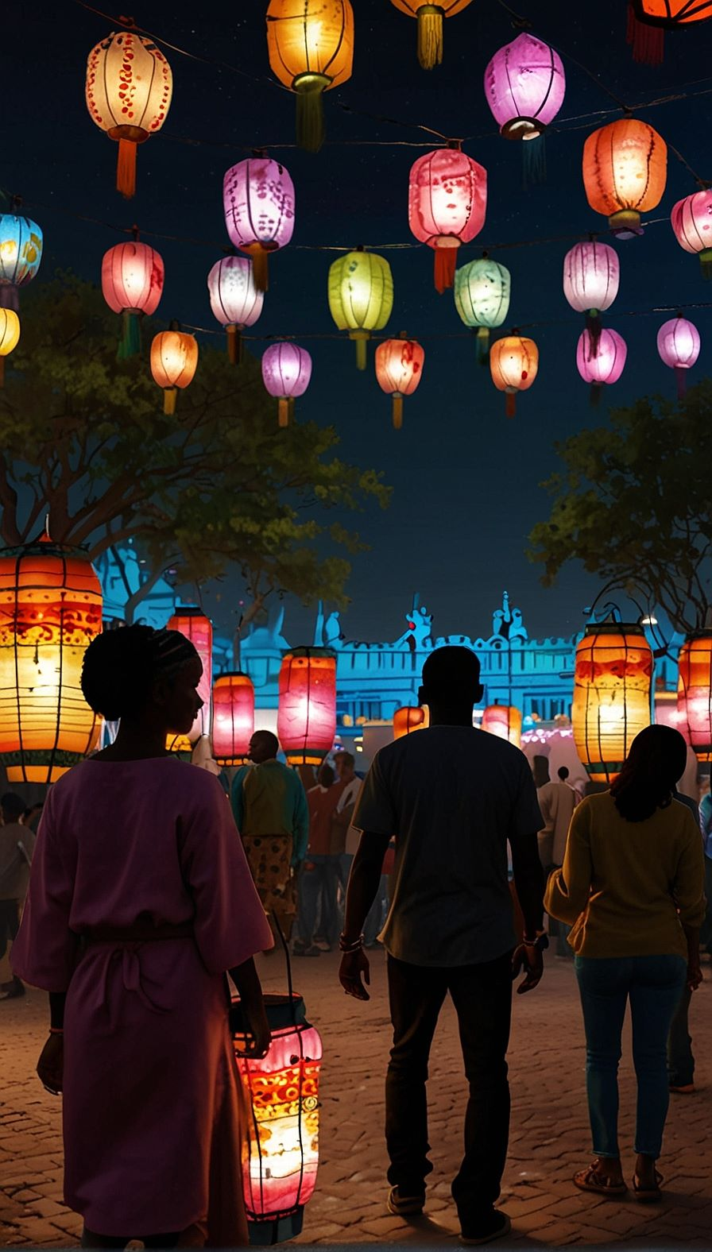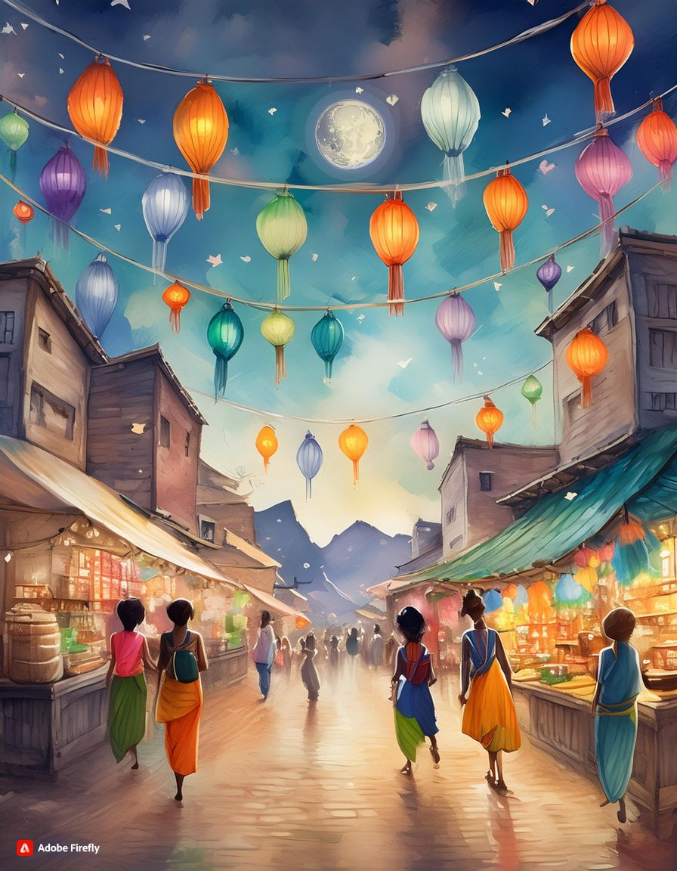

Leonardo.ai

[Leonardo.ai](https://leonardo.ai/) has a strong text-to-image generator that lets you see images as you type, known for being easy to use and flexible.

Here’s the results for my story:



Boosting Your Story with ChatGPT-4o

If you have ChatGPT-4o, it’s great for keeping your story’s characters and themes consistent across all visuals. ChatGPT-4o is being rolled out for free, so keep an eye out for it. Here are some images I made, just using the prompt I created:

Midjourney (Paid)

Can you tell that this is AI-generated?

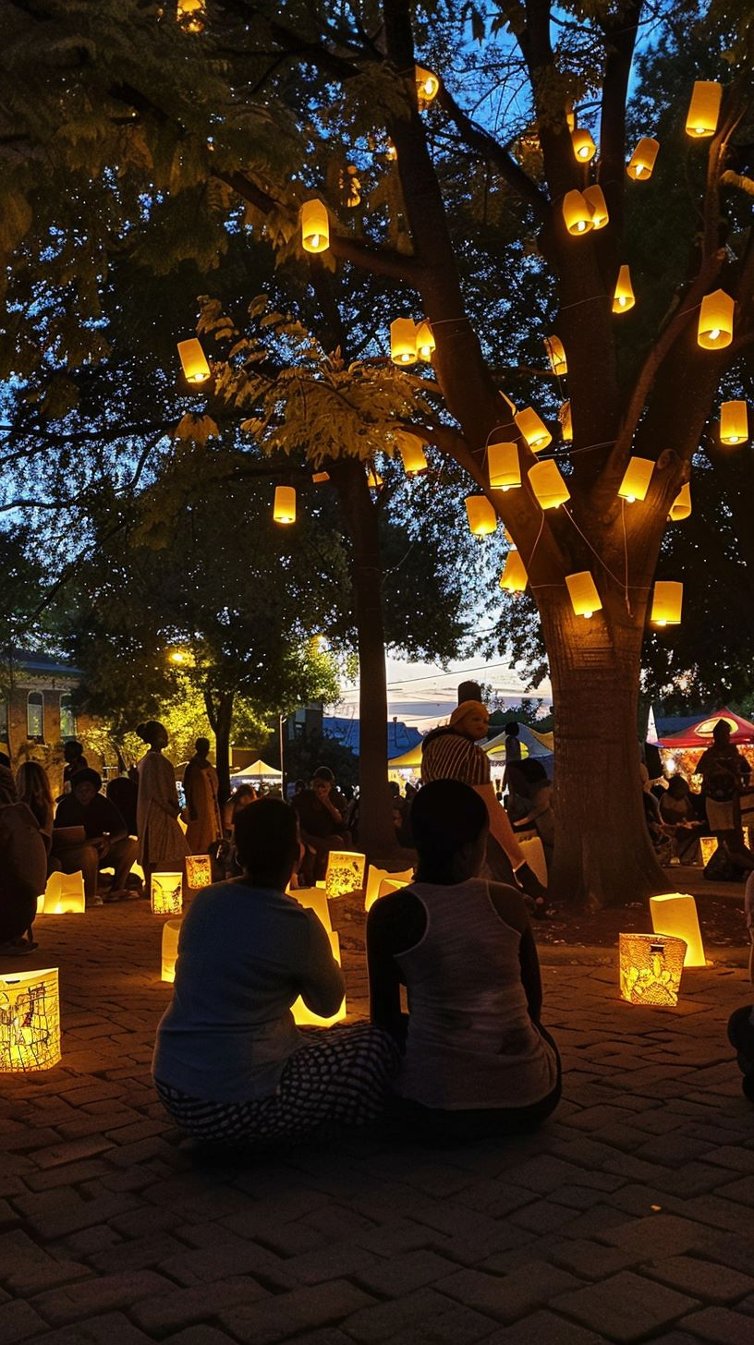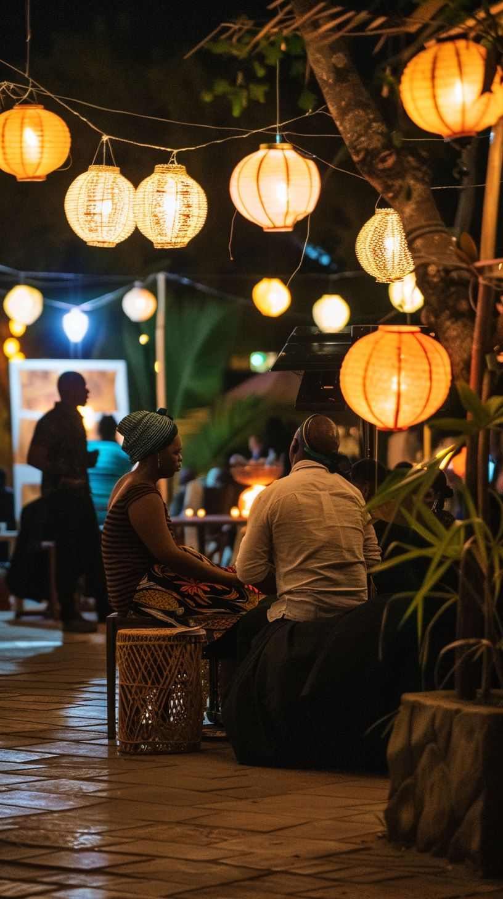

These images might seem real, but they were created using one of the best text-to-image tools, Midjourney. Midjourney is a paid tool, but it is the image generator behind all our story videos and interactive stories in this course.

AI image generation tools are one of the most spectacular uses for AI that has emerged. With these tools, we can elevate our presentation decks, create content for our business, like product placements and ads, and, if you’re fortunate, tell stories at work. Next up, let’s bring these images to life!

# Generating Video with AI



Images are brilliant ways to tell stories and bring life to our work, but videos evoke emotions in people. Moving an image across the screen, makes us feel more connected to a space or characters in a video. However, AI tools still have a long way to go before they can create the perfect video. Still, considering how fast the AI space is developing, it won’t be long until we have AI tools that create videos that are **indistinguishable from reality**.

We’ll highlight two tools to animate images. [LeiaPix](https://www.immersity.ai/" \t "_blank) (now known as Immersity.ai) is a free tool that allows good camera controls. [Pika](https://pika.art/home" \t "_blank) allows us to use text-to-video, image-to-video (with prompts), and even use a video to create more videos!

LeiaPix/Immersity.ai

Head to [Immersity.ai](https://www.immersity.ai/), and follow the guide below to start creating.

Pika.art

Or this example from a previous project:

Our stories now have a visual part, all thanks to AI.

But before we part, reflect on this for a moment:

Reflect:  
How will Generative AI tools affect visual artists and animators?

Donald Glover recently commented that AI allows us to make mistakes faster when creating art, and by rapidly prototyping, we can create a masterpiece faster. He goes on to say, *“everybody’s gonna become a director, and everybody should be a director. ‘Cause at the heart of all of this is just storytelling. The closer we are to being able to tell each other our stories, the more we’ll understand each other.”*

I like that idea, and it ties into what we think the future will be like – **AI will enhance our lives and unleash our creativity.**

# Making Audio with AI



The last piece to create for our story is some **audio**. We played with Udio previously, and it really is the **best music generator available**, so if you’d like to make a tune for your video, head over to [Udio](https://www.udio.com/" \t "_blank).

**Storytelling needs two extra pieces** – **ambient** **sounds** like people talking, water splashing, or electronics humming in the background of Kwame’s lab in my story. The other piece is **speech**. Our video had a script and characters talking in that script.

[Stable Audio](https://www.stableaudio.com/) will help us create music and ambient sound we can use to liven up our video, and [Pika](https://pika.art/home" \t "_blank), the tool we used before, to create voices for our characters.

Stable Audio

Head over to [Stable Audio](https://www.stableaudio.com/), and follow the guide below.  
  
 Here are some of the soundclips I created:

Pika.art

Go to [Pika.art](https://pika.art/" \t "_blank) and follow the guide below.  
  
  
  
This is our narrator Esi, or the voice “Rachel” on Pika:

Now, we have all the pieces we need to tell our story. Visuals capture our imagination, and our characters can now tell their stories!